To Capture Keyboard Input, Handle Backspace, Process Enter Key, Manage Input Buffer, Support Multi-Character Commands, Test User Interaction

Code:

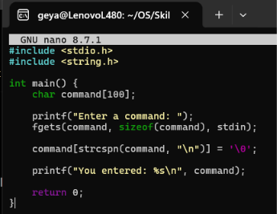

Output:
